Chapter 19, Problem 97.

Synthesize the transfer function

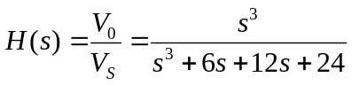

using the LC ladder network in Fig.19.133.

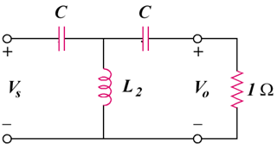
C₁
C₃

Figure 19.133
For Prob. 19.97.

